USER GUIDE
Flex Memberships



TABLE OF CONTENTS

FLEX MEMBERSHIP 3
PRE-REQUISITES 3
SETUP – MEMBERSHIP TYPES 4
SETUP – FLEX WALLET 5
SETUP – POINTS MATRIX 6
SETUP – ASSIGN WALLET 8
SETUP – WALLET BALANCE ...................................................... 9
MEMBER FUNCTIONALITY ....................................................... 11
PAYMENTS ................................................................................. 14
ONLINE PAYMENTS REPORTING ............................................ 15

FLEX MEMBERSHIP

What is Flex Membership?
Flex Membership is a new feature based on the BRS Memberships solution, developed by BRSGolf and GOLFNOW. Flex Membership allows members to have a wallet that holds points, points are deducted for each booking and members can top-up their wallet online.
Flex Membership is a self-managing solution and fully integrated with your BRS Golf payments, teesheet, members website and app. Although it is based on the BRS Memberships solution, Flex Membership can be enabled independently of it.
This document will outline the different parts of Flex Membership which need to be set-up to use the Flex Membership system effectively. To start, navigate to the Memberships area in BRS, then click the Settings icon (highlighted below) in the top right to access the system settings.
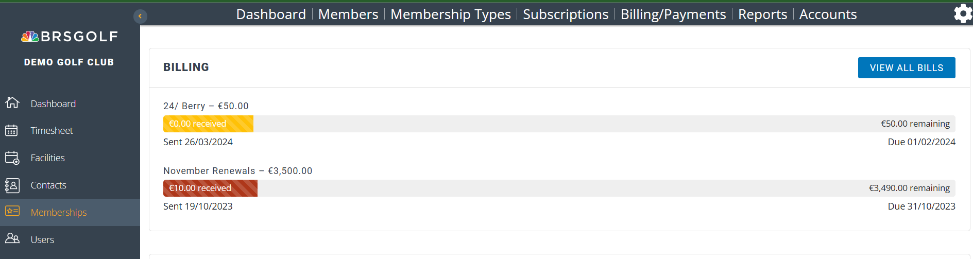
PRE-REQUISITES

Online Payments
Flex Membership uses our online payments solution, known simply as ‘Payments’, to handle online payments.
If your club does not already use our online Payments solution, some setup will be required to create your ‘Payments’ account. This will allow your members to top-up their flex wallet.
The Payments platform developed by BRS is designed specifically for golf clubs and ties into many other aspects of your BRS system. Visitor green fees booked through BRS will be pre-paid online, along with entries into Open Competitions. When paired with our Competition Purse module it can be used to manage Member Competition Payments. Payments also unlocks ‘Virtual Terminal’ and ‘Pay-by-link’ functionality, the latter being a great tool for taking society payments.
If you have not yet completed the set-up of your Payments account, please contact our support team on support@brsgolf.com or your BRS Memberships onboarding contact to arrange this.
SETUP – MEMBERSHIP TYPES

Mark Membership Types as Flex
There is a list of membership types in Tools > Membership Types and in Memberships > Membership Types. Both are kept in sync automatically.
However, you will need to identify the membership type(s) that are Flex Membership.
- In BRS, go to Tools > Membership Types
- Click Edit for the membership type you want to change, tick Flex and click Update.
- In Memberships, go to Membership Types.
- Click Edit for the membership type you want to change, tick Flex and click Update.
- It is important that this is completed in BOTH BRS and Memberships.
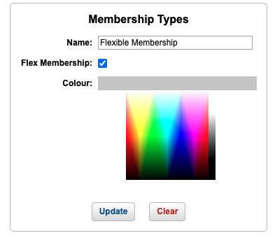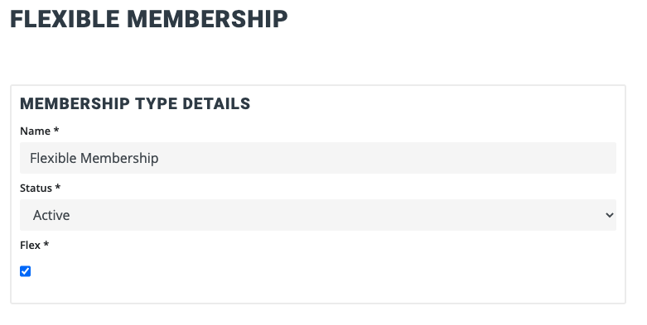

SETUP – FLEX WALLET

FLEX WALLET
Flex Membership supports a single points-based wallet which can be assigned to members.
In Memberships, Settings, click on the Wallet button. Click Create Wallet and complete the relevant fields:
• Name
• Description
• Status
• Unit Type – must be set to Points for Flex Membership.
• Auto assign – set to Yes to automatically assign this wallet to the membership type with Flex set to Yes.
• Credit Limit - Set a negative value to allow a member to be overdrawn or set to zero to prevent someone from overdrawing.
- Member Top-Up Options - this applies to Flexible members topping up points wallets.
• Allow member to type in an amount to top up - tick the box to enable this. Then set the number of points that equals £1/€1.
• Top-up Options – set one or more top-up amounts and the points these equate to.
Click Create to add the wallet or Create and Assign to assign the new wallet to All members, Selected members or Selected membership types.

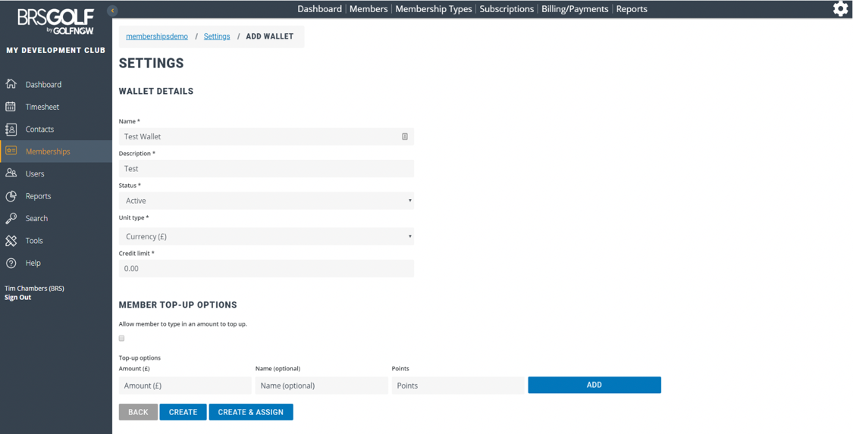

Further points-based wallets can be added to allow for different membership types with different top up values or a different points matrix, but an individual cannot have more than one points-based wallet assigned.
SETUP – POINTS MATRIX

Create a Points Matrix
The Points Matrix is where you define how many points members must “pay” in order to book a tee time. Points will be deducted from the members’ wallet for themselves and any guests they include in their booking. Each flex member will pay for themselves.
To create the Points Matrix, go to Tools > Green Fee Rates and click Add Green Fees. Complete the following fields:
- Category – must be Member
- Subcategory – give the points matrix a name i.e. Flex Members 18h
- Holes – choose either 18 Holes or 9 Holes
- Start Date – set the start date for the rate
- End Date – set the end date for the rate.
- Associate this green fee with membership plans – must be ticked.
  - Choose Selected Membership Types ONLY
  - Then select each Membership type this matrix applies to i.e. each Flex Membership type.
- Click Add Availability and complete the details. You can have multiple availabilities to represent the different price points within a given day, simply click Add Availability for each time band.
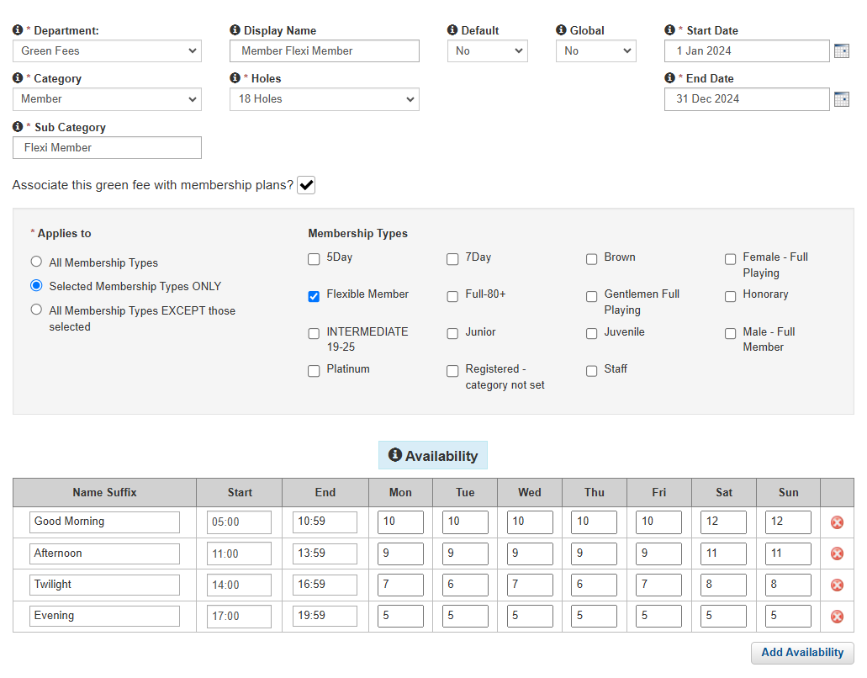
  - Name (optional)
  - Start tee time – set the time to the first tee time or before
  - End tee time – set the time to the last tee time
  - Input the number of points to play Monday through Sunday
    - You can have different points on different days
    - You can leave a day blank which means that members are unable to book in that time band.
- Click Add Override and complete the details. Overrides allow for bank holidays and other dates where the number of points to play would be different than a normal day. Complete the details
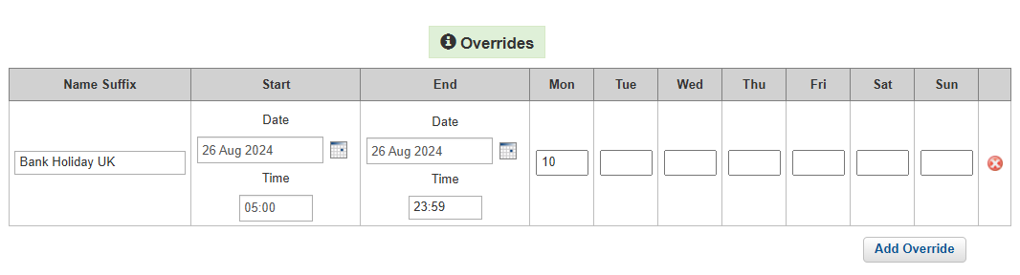
  - Name (optional)
  - Start Date – set the date the override applies to
  - Start tee time – set the time to the first applicable tee time
  - End Date – set the date the override ends. This can span multiple days
  - End tee time – set the time to the last applicable tee time. If the override spans the whole date the tee times can be set to start at 05:00 and end of at 23:59.
  - Input the number of points to play
    - Where the date is a single day, input the points into the corresponding day of the week
    - Where the dates span multiple days, input the points into each day that applies.
  - Click Update to save changes.
NOTE: It is important to create a Points Matrix for non-flex members that has 0 as the number of points applying each day. Simply follow the steps above, selecting non flex members when associating the green fee with membership plans.

SETUP – ASSIGN WALLET

Assign a Wallet
When you add new Flexible Members to the system you will need to assign wallets to their profile unless you have set the Wallet to be auto assigned. In Memberships, the actions column in the Flexible Members panel on the dashboard will identify any member that doesn’t have a wallet assigned yet.
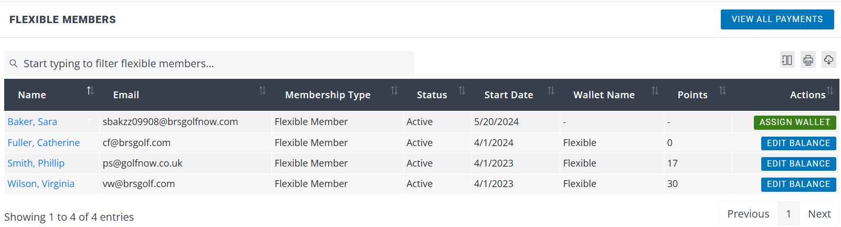
You can sort the list of members by clicking on the column name, in the above example click on Actions to display all members that have Assign Wallet first.

Click on the Assign Wallet button, which takes you to the Wallets page in Settings.
- From Actions, click + to assign the wallet.
- The name of the wallet to be assigned will appear on screen.
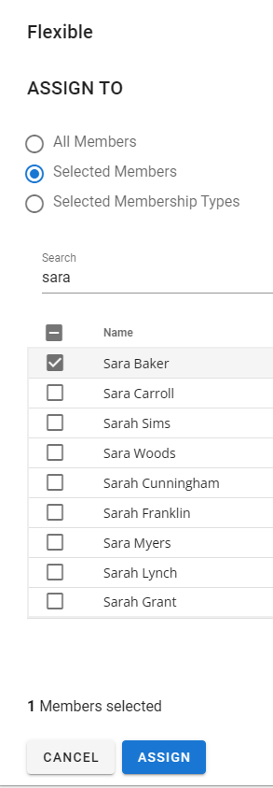

- If you choose Selected Members, you assign the wallet to an individual member
  - Use the filter to find the member in the list by typing their last name or firstname
  - Select the member in the list
  - Click Assign

- If you choose Selected Membership types, you will assign the wallet to all members within the membership types that don’t already have a wallet assigned.
  - Use the filter to find the membership type in the list
  - Select the membership type in the list
  - Click Assign

SETUP – WALLET BALANCE

Edit a Members Balance
At any time, you can edit the balance in a members’ wallet. You may do this to create an initial balance, to top-up their wallet from a cash payment, to top-up their wallet with competition winnings or to clawback any unused points.
Firstly, find the member record:
- Through the dashboard
  - Scroll to find the member in the list
  - Click Edit Balance
- Through the Members page
  - Use the filter to find the member
  - Click on their name
  - Click Account Balances
  - Click Edit Balance
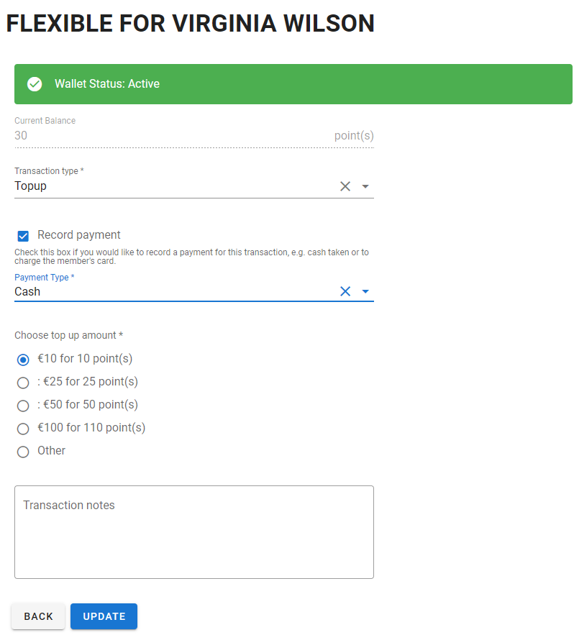
Complete the details as follows:
- Transaction type
  - Topup – adds extra points to the members wallet
  - Clawback – reduces the members wallet
  - Transfer – Not applicable for Points Wallets. Used to transfer currency from one currency wallet to another.
- Record payment – tick this box if you want to record a payment transaction for this topup. If you are transferring existing balances from another system, you should untick this box.
- Select payment type
  - Online – use this to take a payment using the member’s card details. The system will ask you to complete the members card number, expiry date and cvc.
  - Any other payment method – sets the payment method to display for the topup transaction.
- Top up Amount – select the amount from the options available or select Other to input a different number of points - this MUST be points. If you have received a cash amount don’t forget to convert that to points, based on the value you set in the Flex Wallet setup.
- Transaction Notes – put a description of the transaction. These notes will be visible to the member in their wallet transactions.
- Click Update to save and apply the changes.

MEMBER FUNCTIONALITY

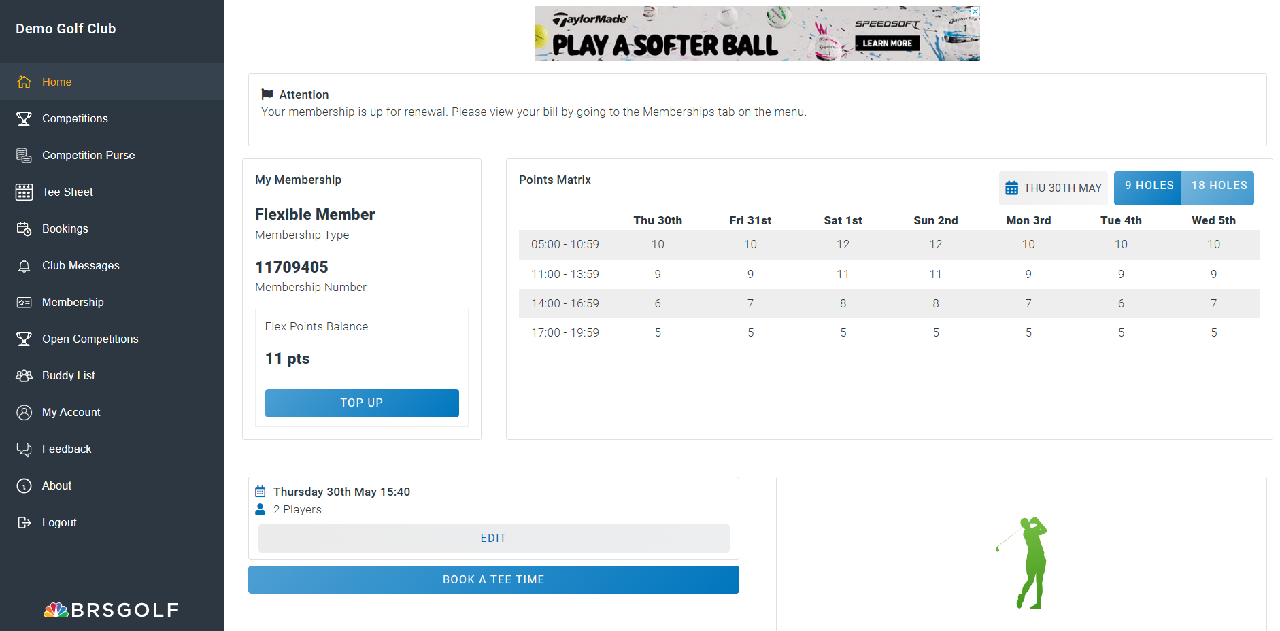
New Functionality for Members
Your flex members will be able to view their Wallet Balance and the Points Matrix through their existing member login.
Points Matrix
The Points Matrix displays the number of points it will cost to play for the next 7 days in the time bands you have created. If you have both a 9 and 18 hole points matrix, the member can flick between them by clicking or tapping 9 Holes or 18 Holes.
If the member wants to view beyond the 7 days that are displayed, they can click on the calendar and select their preferred date. The points matrix will refresh and display the selected date as the starting date.
MEMBER FUNCTIONALITY contd

Make a Booking
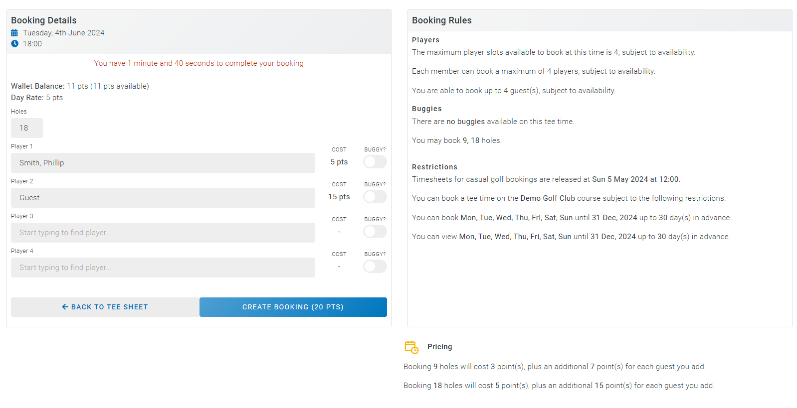
When a member makes a booking, either for a competition or for casual golf, points will be deducted from the members wallet for themselves and any guests they include in their booking. Flexible members pay for themselves through their own wallets.
Guest rates can also be added using a Points Matrix in Tools > Green Fee Rates.
The booking details displays the number of points the tee time will cost, highlighted above. Once the booking completes, the points will be deducted from the member’s wallet.

MEMBER FUNCTIONALITY contd
Top Up a Wallet
When the member has insufficient funds to make a booking, they will need to top up their wallet. On the Home page they can click Top Up:
On the next screen, click on + to top up that selected wallet.
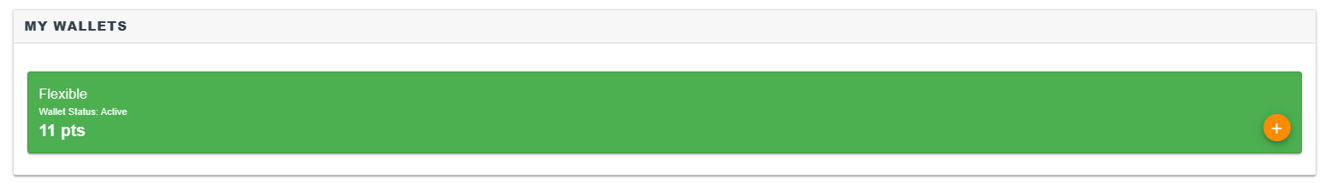
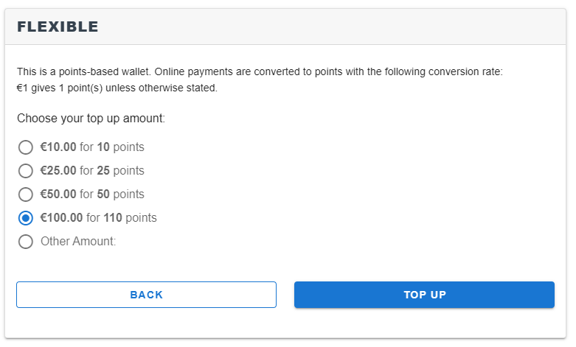
Choose the amount they wish to top up or choose Other and input the amount (as defined in the Wallet setup).
- Click Top Up - the member must complete all the mandatory fields on the Integrated Payments page, mandatory fields are marked with *.
- Complete Card Number, Expiry month/year and CVC
- Click Pay Bill
- The payment completes and the wallet is topped up. If there are any issues with the card this should display on screen to the member. The member will receive an email confirming payment for the top up.
- Note that the card details are stored in the member’s associated Stripe account. Any future top ups will use the stored card details; however the member can change their card details at any time by going to Membership, Dashboard and click Update Card Details.

MEMBER FUNCTIONALITY contd

Wallet Transactions
Members can view their wallet transactions through Membership > My Wallets. All wallet top ups and purchases are shown for the last 30 days but can be extended to 90 days.
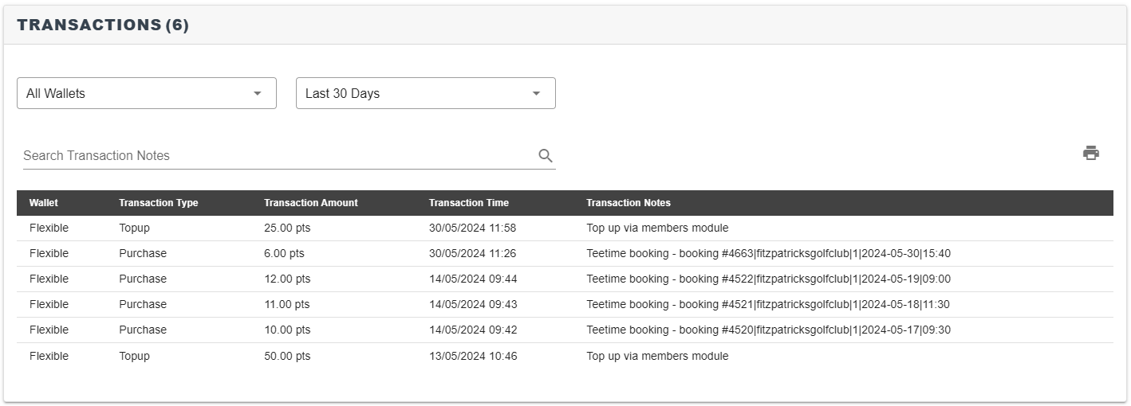

PAYMENTS

Viewing Payments
To view all payments that have been received for top ups, follow these steps:
- Navigate to Memberships, then choose the View All Payments option on the Flexible Memberships dashboard.
- You can search for a specific member name, payment date range, payment type, status, membership type.
- Filter by Payment Groups to remove any Bill Payment or Wallet Currency payments, leaving Wallet Points as the selected option.
- The data can be exported in a spreadsheet by clickin the download icon ()
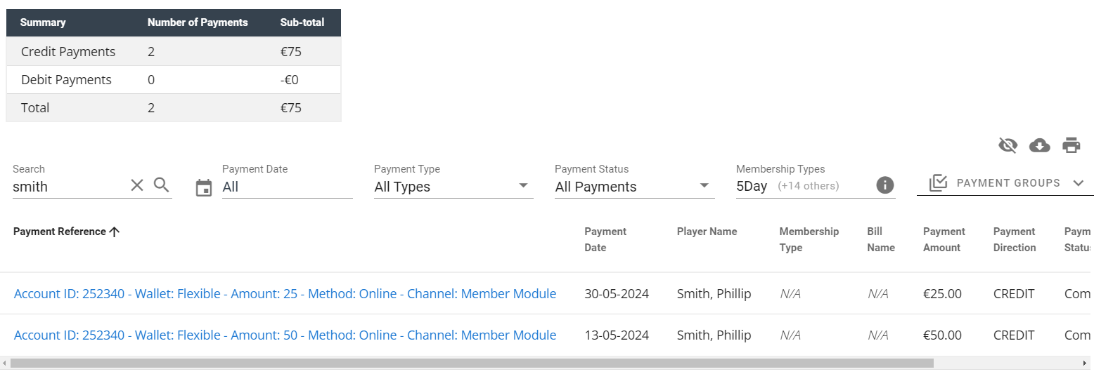

The data is divided into several columns:
- Payment Reference - this is automatically generated and provides some brief information on the payment.
- Payment Date - the date on which the payment was made.
- Player Name - name of the member the payment relates to.
- Membership Type – Displays the membership type of the member (only for a bill payment)
- Bill Name: Displays the bill name if the payment was towards a bill
- Payment Amount - the value of the specific payment.
- Payment Direction - Credit indicates money coming in, Debit indicates outgoing money from the likes of a refund.
- Payment Status - shows if the payment has been Completed, Cancelled. Scheduled, or if there has been an error with the attempted payment.
- Payment Type - shows the method of payment, note that ‘Online’ means indicates the payment was made through the online payments platform.
- Note: Displays any notes added when recording the payment

ONLINE PAYMENTS REPORTING

Online Payments Reporting
As previously mentioned in this guide, the Flex Memberships module uses our online payments platform known simply as ‘Payments’ to handle online payments. The Payments platform is also used to handle online open competition payments, visitor green fees, and payment request emails.
To report on online payments made by members for their top ups, follow these steps:
- Log in to BRS.
- Navigate to the Tools area.
- Scroll down to the grey coloured block of tools titled ‘BRS Payments’.
- Click on the Payouts tool.
- Click on the value in the Amount column.
You will see a table with detailing the payments and fees included in this payout. Payments which have been made via the Flex Memberships system (and their corresponding fees) will be flagged as ‘Memberships_PointsWalletTopUp’ in the Source column.
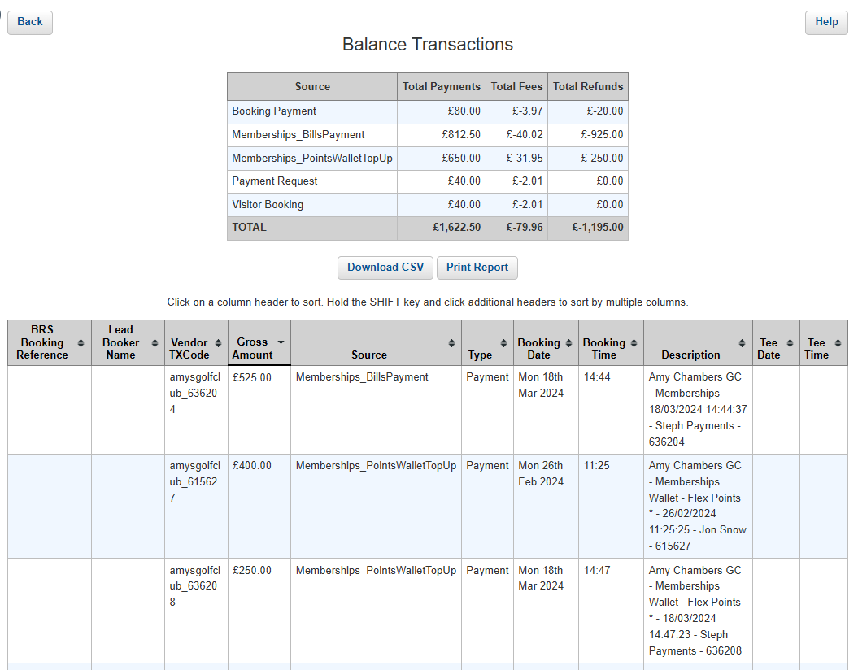
This data can be sorted by clicking on a column and can also downloaded in spreadsheet (CSV) format or printed by using the respective buttons in the above screenshot. Payouts are paid into your nominated bank account on a rolling, 7-day schedule each Monday.

